**Assessment Cover Page**

|  |  |
| --- | --- |
| *Student Full Name* | Monica Silva |
| *Student Number* | 2024446 |
| *Module Title* | Strategic Thinking |
| *Assessment Title* | CA 1 – Capstone Project Proposal |
| *Assessment Due Date* | 27/10/2024 |
| *Date of Submission* | 24/10/2024 |

**Declaration**

By submitting this assessment, I confirm that I have read the CCT policy on academic misconduct and understand the implications of submitting work that is not my own or does not appropriately reference material taken from a third party or other source.

I declare it to be my own work and that all material from third parties has been appropriately referenced.

I further confirm that this work has not previously been submitted for assessment by myself or someone else in CCT College Dublin or any other higher education institution.

Contents

Introduction 2

Objectives and Problem Definition 3

Project Scope 3

Explore Data: 3

Data Preprocessing: 3

Model Development: 3

Model Evaluation: 4

Document Processes: 4

Boundaries 4

Data Sources 4

Timeline 4

Ethical Considerations 5

References 5

# Introduction

Introduction

In the energy-economic sector, regulation involves a set of measures designed to guarantee stable behavior, and is a fundamental pillar of public policy in various countries. The international market presents a variety of perspectives and methods, each with its own motivations.

Stakeholders in the energy sector face a complex web of interests, including environmental sustainability, economic development, imports of primary materials and the quest for electrical independence. These interactions are affected by unpredictable fluctuations in commodity prices, especially in the current context.

In the last five years, the price of gasoline in Brazil has risen by 66%, while the minimum wage has risen by only 27%. This mismatch is alarming, especially with the reintroduction of PIS/COFINS taxes on gasoline on March 1, 2023, which raised the price of a liter by R$0.47. According to the Ministry of Economy, the average price of gasoline was R$5.08 at the beginning of February 2023, and the return of the tax caused this figure to rise to R$5.55 per liter



*Fig 1: shows the different prices in each state of the country and which state has the most expensive gasoline in the country before the end of the tax exemption*

# O que é o tráfico internacional de pessoas

O tráfico de pessoas é quando uma pessoa é enganada para serem levadas para outros países em sua maioria para fazerem trabalhos escravos como serem forçadas a trabalhar sem receber ou serem exploradas sexualmente e sem contar os que matam para roubarem os órgãos. Quando a pessoa cai num desses golpes é porque ela foi enganada e esses tipos de golpes vem acompanhada de propostas de emprego ou através de um “namorado online”.

A Organização das Nações Unidas (ONU), no Protocolo de Palermo (2003), define tráfico de pessoas como “o recrutamento, o transporte, a transferência, o alojamento ou o acolhimento de pessoas, recorrendo-se à ameaça ou ao uso da força ou a outras formas de coação, ao rapto, à fraude, ao engano, ao abuso de autoridade ou à situação de vulnerabilidade ou à entrega ou aceitação de pagamentos ou benefícios para obter o consentimento de uma pessoa que tenha autoridade sobre outra para fins de exploração”.

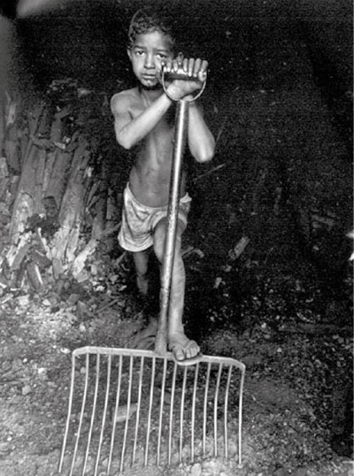

## Chapter 1.1

### Chapter 1.1.1.

[NOTE: For the table of contents to function properly, you must use the correct headings for all your chapters and subchapters.

**Heading 1:** This is the main heading and should be employed for the primary title or chapter. For example: CHAPTER 1.

**Heading 2:** Use Heading 2 as a subheading. For instance: Chapter 1.1.

**Heading 3:** Heading 3 provides a more detailed breakdown, such as Chapter 1.1.1.

By adhering to this hierarchical structure, you ensure an organized and effective document outline, enhancing readability and navigation. However, you are not forced to use all 3 headings, usually heading 1 and 2 are sufficient.

The remainder of your text should be written using a normal font.]

# References